This report provides an end-to-end IoT system analysis of the TP-Link Tapo C210 Pan/Tilt Home Security Wi-Fi Camera, covering its architecture, communication, security, and performance. [1, 2, 3]
1. System Overview: Remote Monitoring Functionality
The Tapo C210 is a 3MP (2K) smart home camera that provides real-time, remote surveillance. [1, 2, 3, 4, 5]
- Remote Monitoring: Users access live feeds anywhere via the Tapo App.
- Interaction: Features two-way audio (microphone/speaker) and remote pan/tilt controls (360° horizontal, 114° vertical).
- Smart Alerts: Motion detection, person detection, and baby crying detection trigger instant notifications and recording.
- Storage: Supports local storage (microSD up to 512GB) and cloud storage (Tapo Care). [1, 2, 3, 4]
2. Architecture Design
The Tapo C210 utilizes a 4-layer IoT architecture: [2]
- Device Layer (Physical): The camera itself, equipped with a 3MP CMOS sensor, motorized pan/tilt, speaker, microphone, infrared LEDs, and a microSD slot.
- Connectivity Layer: 2.4GHz Wi-Fi (IEEE 802.11b/g/n) connects the camera to the home router.
- Edge Layer (Local Router/Bridge): The local home router acts as a gateway, facilitating local RTSP streaming and managing traffic between the device and the cloud.
- Cloud Layer: TP-Link cloud services handle user authentication, P2P connection brokering, firmware updates, and optional Tapo Care cloud storage.
- Application Layer: The Tapo App (Android/iOS) provides user control, live viewing, playback, and alert management. [1, 2, 3, 4, 5, 6]
IOT Architecture Diagram
(Device: Camera) -> (Connectivity: Wi-Fi) -> (Edge: Router/Cloud Gateway) -> (Cloud: Tapo Servers) -> (App: Smartphone) [1, 2, 3, 4, 5]
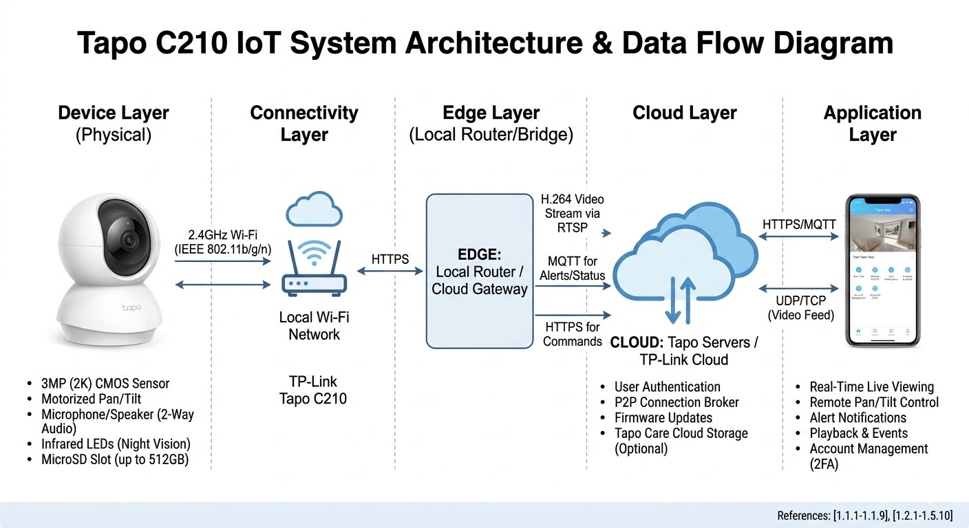
3. Data Flow Analysis
The system handles three distinct types of data flow:
- Live Streaming Flow: The camera captures video, compresses it (H.264), and sends it to the cloud/app via P2P (UDP/TCP).
- Control Command Flow: App commands (e.g., move camera) are sent via HTTPS/MQTT to the cloud, then pushed to the camera.
- Alert/Event Flow: Motion detection (sensors) triggers the camera to push a notification and a short clip to the cloud, which pushes it to the phone. [1, 2, 3, 4, 5]

4. Protocol Identification
- Physical Layer: 2.4 GHz Wi-Fi IEEE 802.11 b/g/n.
- Application Layer: HTTP/HTTPS (control and management), MQTT (lightweight messaging/alerts), RTSP (Real-Time Streaming Protocol).
- Transport Layer: TCP (reliable delivery for commands), UDP (speed/live video streaming). [1, 2, 3, 4, 5]
5. Performance Evaluation
- Latency: Live viewing generally experiences low latency (<1s on local networks), though remote viewing may face 1-3s delays based on cloud relay traffic.
- Bandwidth: The 3MP resolution requires significant upstream bandwidth for high-definition streaming, potentially affecting other home devices.
- Reliability: Highly reliant on stable Wi-Fi. It uses local storage (SD card) as a failover when the cloud connection drops. [1, 2, 3, 4]
6. Security Analysis
- Authentication: The Tapo app supports 2-Factor Authentication (2FA) for user accounts.
- Encryption: The camera uses TLS 1.2 to secure internet connections and AES 128-bit encryption for video and data, preventing unauthorized access.
- Privacy Control: A physical Privacy Mode can stop surveillance and hide the camera lens.
- Compliance: The system adheres to ISO 27001 and ISO 27701 standards.
- Vulnerabilities: While secure, IoT devices are potential targets for network-based attacks; proper firewall and router security are essential. [1, 2, 3, 4]
7. Comparative Study: Local vs. Cloud vs. MQTT Systems
Feature [1, 2, 3, 4] | Local Storage (SD) | Cloud Storage (Tapo Care) | MQTT Control (Cloud)
Latency | Extremely Low | Moderate | Low
Bandwidth | None (Upload) | High | Minimal
Security | Physical Security | Encrypted Cloud | Encrypted Cloud
Flexibility | Limited to home | Accessible anywhere | Real-time control
Cost | One-time cost | Subscription | Often included
8. Advanced Exploration: Edge Processing and Scalability [1]
- Edge Processing (AI): The C210 performs local motion detection and baby crying detection, reducing the load on the cloud by only sending relevant data, which improves scalability.
- Scalability Improvement: To support more cameras, a localized NVR (Network Video Recorder) using the ONVIF/RTSP protocol can reduce the bandwidth strain on the internet gateway, relying on local storage. [1, 2, 4]

References
- [1.1.1-1.1.9]: IoT Architecture Concepts.
- [1.2.1-1.5.10]: Tapo C210 Specifications, Features, Security, and Technical Data. [1, 2, 3]

